Workshop Readiness Form
Venue Readiness
Venue address
Conference room name
Room set up diagram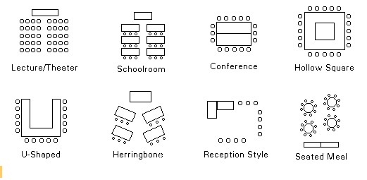
Audio visual needs
- Easel / flip chart stand
- Flip chart paper
- Lectern / podium
- Projector
- Projector screen
- Wireless signal
On site contact details
Parking logistics
Security requirements
- Badges
- Roster
Class
Prep arrival date
Event date start
Event date end
Start time
End time
Last day to register
Participant opt-in/out contact by vendor
Participants
Minimum amount of participants
Maximum amount of participants
Gratis participants
Prep work or materials to bring
Food and Meal
Who makes pays / receipt?
Catering vendor contact details
Breakfast
Lunch
Dinner
Afternoon snack
Beverages
Travel accommodations and lodging
Who pays for travel and accommodations?
Nearby hotel
Closest airport
Transportation
Materials
Who pays for photocopies?
What date should the copies be ready?
Copies
- One sided
- Two sided
- Color
Branding and logo
Post training access to content
Evaluation / classroom survey

